**Group 4 Project 1 Write-Up**

For the first project of the bootcamp we decided to go with a 1994 dataset from Adult Census dealing with income. The dataset has multiple columns of data that outline each person’s demographic information. Along the way, we had asked ourselves multiple questions that could be answered through analyzing the dataset. The main concept from the dataset lies in determining what socioeconomic factors play a part in someone making above or below $50,000 in 1994.

**Question One: In a 1994 dataset, how do women stack up against men in regard to making over $50k?**

As mentioned, the dataset contains multiple columns of data that give us an inclination of drivers that result in making above or below $50k. First, we took a look at gender. Although only having two variables (boy or girl), we were able to start the project off with an understanding of what we were working with. It has to be remembered that this dataset is a result of 1994 where a majority of women have not yet fully joined into the workforce. When pulling the value count for sex, we see the output there are over 20,000 males included in this dataset as opposed to only 10,000 females. As seen in the chart below, roughly only 11% of women are making $50k a year. It can be shown by this chart that men made significantly more money than women in 1994 and were more of the share of the workforce.

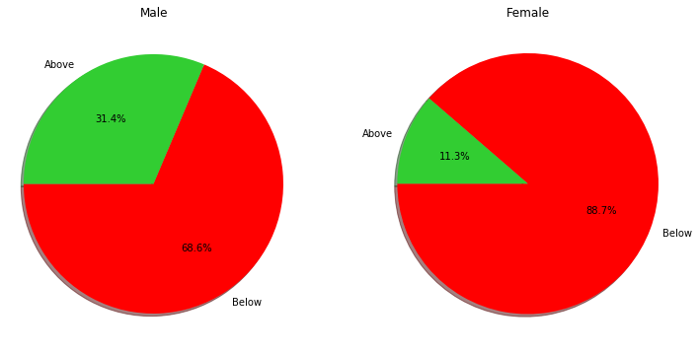

**Question Two:** **Does attaining higher education result in making more money?**

This question was something that was a bit predictable, but there were aspects our group found surprising. The x axis is labeled with minimum level of education, and the y axis is labeled with the percentage of people in the dataset who make above or below $50k. As seen in the chart below, people who have a Master’s degree have the highest likelihood of making more than $50k. A factor that doesn’t get taken into consideration in the dataset is how much debt each person owes, if that was factored in, perhaps it would show that attaining a Master’s degree may not be worth the salary vs debt. Something that surprised our group was the fact that people who hold Doctorate degrees have about the same likelihood of making above $50k as the group who hold Associate’s degrees.

When testing the data, we see there is virtually no difference between Bachelor’s and Master’s degrees. When running z-tests and p-score to test the statistical differences, after conducting the tests we determined that there is not a statistical difference between the two degrees **(z-score: -1.3169, p-value: .1879**). The question arises, is it worth it to try and further your education after getting your Bachelor’s degree? According to our analysis, it does not seem the case.

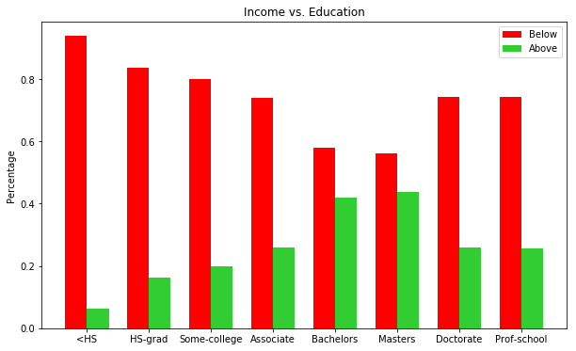

**Question Three: Was the country as diverse in 1994 as we know it now in 2018? Does the race that has the most people reflect in making the most money?**

Easy answer, no, the country was not as diverse as today. When value counting race, it shows that Whites represent **85% (27816/32561**) of the data set. Interestingly enough, although Asians only represent 3% of the data set, they have the highest likelihood of making more than $50k. When testing the data through z-score and p-score **(z-score: -.9876, p-score: .3234),** we see there isn’t much of a difference between White and Asian people, but the fact that Asians represent a significantly lower number of the data set and have a higher percentage of people making over $50k is pretty remarkable.

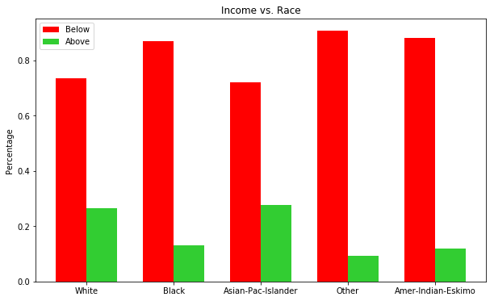

**Question Four: Does it financially make sense to get married?**

So, this question is something we’ve been asking our entire lives. The data sets analyzed during this question was marital and relationship status vs income. As the chart clearly states, those who are married are the most prone to make over $50k a year. What we found interesting about comparing this to another analysis, relationship status, was that wives have a higher percentage of making more money than husbands. When tying this back to our gender analysis, only 11% of women made over $50k but it is safe to say that at least over 5.5% of those women are married. In conclusion, yes, it does financially make sense to get married when looking at the number of husbands and wives who make over $50k.

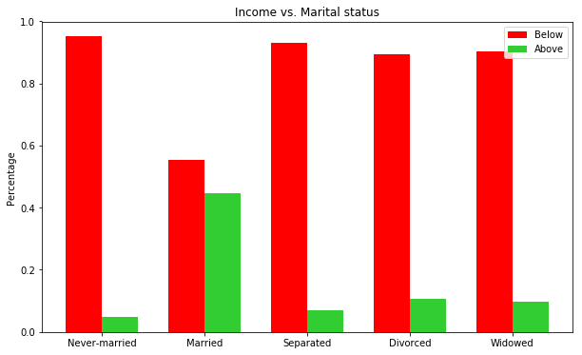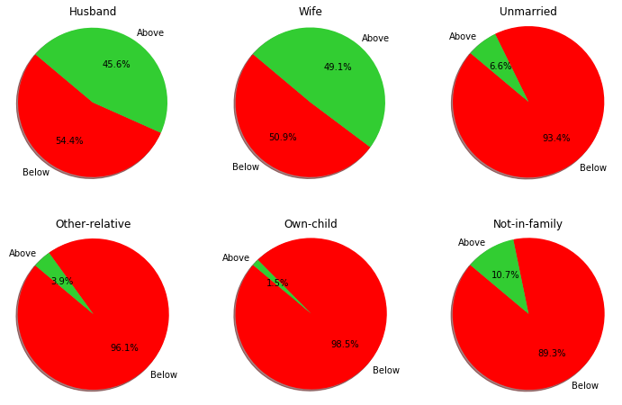

**Question Five: Does it make sense to go the safe route as opposed to taking a chance on building a business?**

When we proposed the above question, this was essentially what had the most uncertainty around it. When analyzing the data, does it make sense to go into a safe career as opposed to taking a risk and starting your own company? Note, we had a “without pay” column of data that we dropped from the data set as it was not telling for our analysis. Once that was dropped, we took a look at all the work classes provided in the data set to see if it makes sense to start a business. There were two data sets that represented self-employment, Self-employment Incorporated and Self-employment Not Incorporated. Obviously being self-employed is the much higher risk due to the financial uncertainty, but those who are self-employed have about a 44% chance of making more than $50k. It seems as though the risk could be worth it when looking at ¾ “safe” work classes have 70+% chance of making less than $50k.

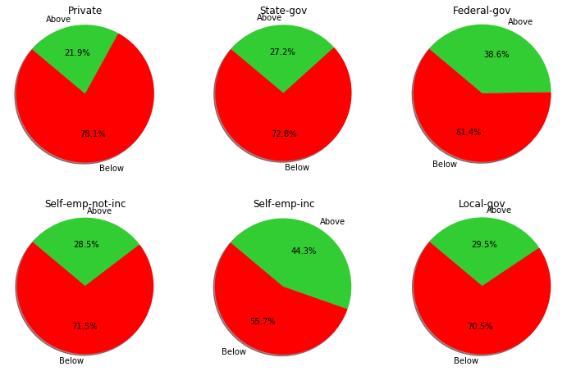

**Question Six: What age do you hit your financial peak?**

There are a lot of factors to think about when discussing age vs income. In your 20-30s people tend to be finishing up or entering school and just starting their careers. It can be determined from the dataset and the below chart that the financial peak of life is likely between the ages of 40 and 50. We’ve tested the dataset and realized that statistically there is no difference between likely making over $50k if you are either 40 or 50 years old. The downward trend from ages 60-80 was definitely expected as many people begin collecting Social Security and therefore start taking a lumpsum of what they typically make while working full time. In conclusion, per the charts below and the dataset provided we can conclude that people who are considered to be in the middle stages of life tend to have the highest probability of hitting their financial peak.

